**Strategy about future**

**Material and Human resource**

Even there are increasing need for access to charging stations the biggest thing that impede the built out of such a strong charging station network is high cost of equipment and installation. The main categories of charging station can be listed as; actual charging station hardware; other hardware and materials; electrician and other labor; mobilization; and permitting. You can see the shares of these categories on figures below.

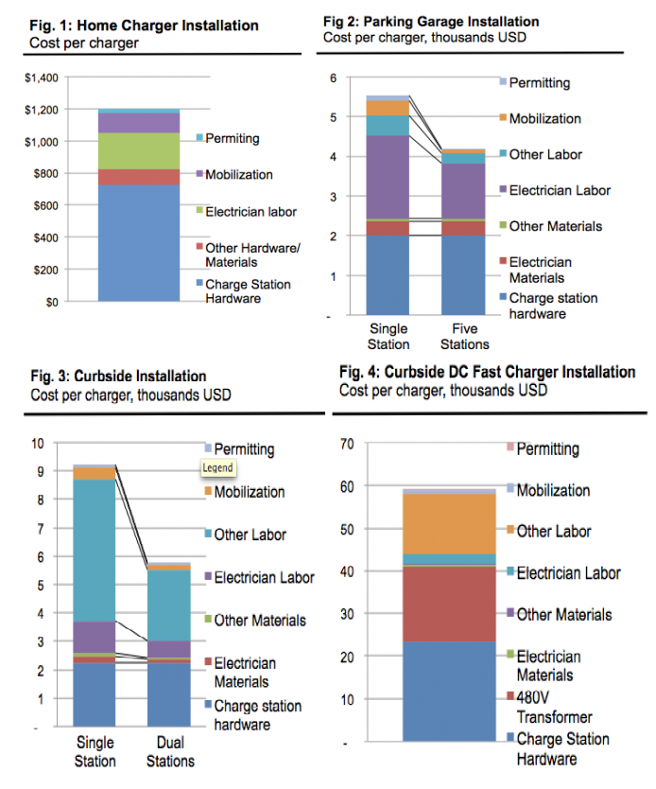

Some other costs are not included in these research such as; general and administrative overhead, which easily can contribute 20 percent or more to costs but which also reduce rapidly with experience; other miscellaneous costs, such as wage requirements for federally funded projects, which can add 15 percent to 25 percent to costs; or financing (and other costs of capital/debt) for charging station owners. [1]

**EVs battery**

**Charging speed**

**Home battery**

**Maintenance**

**Payment system and Price**

**Blockchain technology**

**cost of charging station**

[**http://blog.rmi.org/blog_2014_04_29_pulling_back_the_veil_on_ev_charging_station_costs**](http://blog.rmi.org/blog_2014_04_29_pulling_back_the_veil_on_ev_charging_station_costs)

1. [**http://blog.rmi.org/blog_2014_04_29_pulling_back_the_veil_on_ev_charging_station_costs**](http://blog.rmi.org/blog_2014_04_29_pulling_back_the_veil_on_ev_charging_station_costs)